Application: 0812053250

SeethaLakshmi Kuppuraj - [akila.sankar@winvinayafoundation.org](mailto:akila.sankar@winvinayafoundation.org) India Fellows Program

**Summary**

**ID:** 0812053250

**Online Application Form**

**In Progress** - Last edited: Nov 1 2023

**Online Application Form**

**C: ABOUT YOUR WORK**

In this section, we will ask you more about the focus, stage of your current organisation or initiative, and learn about how your specific activities and interventions are having a meaningful impact on the people or institutions you work with. This will help us better understand where lessons from the Fellowship Programme could be applied in real life to support and elevate your work.

Please use the questions below to describe the approach and the impact of your organisation/initiative in detail. If you aren’t a CEO, Co-founder or in an Executive level position, please answer questions related to your particular department/project where relevant. If you work across multiple organisations/initiatives, please complete your application for the work you spend the majority of your time on.

# Basic Information

### * What is the name of the organisation or initiative where you are working?

WinVinaya Foundation

*If you don’t have a website or social media links, please mention N/A*

|  |  |
| --- | --- |
|  |  |
| Website | <https://winvinayafoundation.org/> |
| LinkedIn | <http://www.linkedin.com/company/winvinaya-foundation> |
| Facebook | <https://www.facebook.com/WinVinayaFoundation> |
| Other | <https://instagram.com/winvinayafoundation/>, <https://twitter.com/WinvinayaF> |

### ** Do you work in any of these sectors below?

*Please see the* [*attached*](https://drive.google.com/file/d/1X8aLyEwKQJb7i8I01bvIVIFed1uQiTCB/view?usp=sharing) *document for definitions of these sectors.*

*Working in any of these following sectors is not a requirement to become an Acumen Fellow. We collect this data to allow comparison with other regions. We understand that this breakdown is not exhaustive.*

*Please select one that is the closest and you will have more opportunity in the remaining part of this application to share about your work.*

Skills Development, Diversity Equity and Inclusion

### * Select the best option that describes the main focus area(s) of your organisation or initiative. You may select multiple if appropriate.

*We understand that this breakdown is not exhaustive. Please select the closest and you will have more opportunity in the remaining part of this application to share about your work.*

*Please limit your choice to 3 options.*

## No Responses Selected

*Please see the* [*attached*](https://drive.google.com/file/d/1X8aLyEwKQJb7i8I01bvIVIFed1uQiTCB/view?usp=sharing) *document for the definitions of the models.*

Not for Profit Entity

**\*\* Please select the activity type for your organisation/initiative:**

Technology

**\* Is your organisation registered as a legal entity?**

Yes

**\* How long has the organisation or initiative been in existence for? (As a legal entity)**

*Please round off to the nearest whole number. (i.e. 6.5=7, 6.2=6). Additionally, if it has been registered as a legal entity for more than 10 years, please choose 10.*

8

### Is your organisation/initiative part of a larger corporate, government, or nonprofit entity?

No

*Please add the whole number here (5, 26 etc). Please include yourself.*

|  |  |  |
| --- | --- | --- |
|  | Full Time Paid | Part-Time/Volunteers |
| Organization Staff | 40 | 10 |

# Help us understand your work’s financial sustainability

### What has been your organisation’s or initiative’s primary source(s) of funding over the last 1-3 financial year(s)?

*Select any funding sources that represent >20% of your total revenue/budget. Please tick N/A if unknown to you.*

*Please limit your choice to max. 3 options and note that even if you can tick more than 3, you won’t be allowed to move forward after completing this section.*

## Responses Selected:

|  |
| --- |
| Corporate Grants |
| Individual Donations |
|  |

### To what extent is your organisation/initiative funded by grants or donations?

Almost all our funds are from corporate grants or individual donations. - This option is not given-look at the options given below

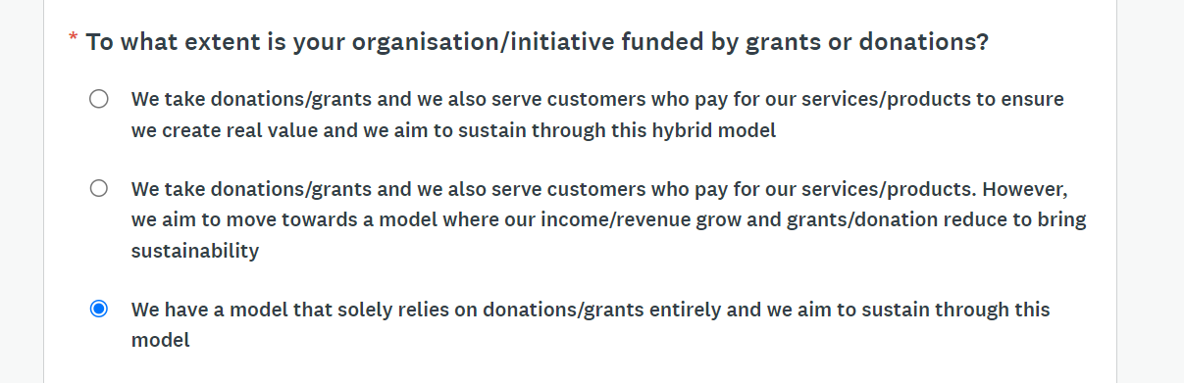

## How much funding (including equity, debt, grants, and any other kind of financing) have you raised since your organisation/initiative is in existence?

*If you aren't a CEO, Co-Founder, or at an Executive level role in the organisation, please share details about your department/initiative specifically.*

*Please don’t include any revenues or any self funding in this calculation*

From FY 2015-16 till FY 2022-23, grants/ donation raised is about Rs 4.7 Crores or $567,669 - Options are given below

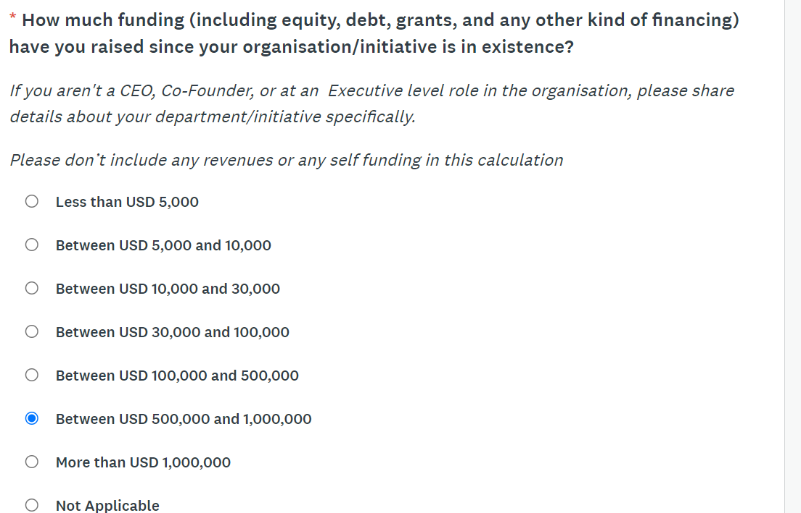

### Can you please help us understand the following for your organisation/initiative:

*If you aren't a CEO, Co-Founder, or at an Executive level role in the organisation, please share details about your department/initiative specifically.*

*Please mention “0” if you don’t have these numbers*

|  |  |
| --- | --- |
|  | Last Year |
| Total Annual Operating Budget (USD) | US$ 200,483 (Un-audited)  USD-INR Conversion Rate assumed: Rs 83 |
| Revenue Generated (USD) If any | US$ 193,916 (Un-audited)  USD-INR Conversion Rate assumed: Rs 83 |

### If you have entered “0” in any field above, can you please share further details about unavailability of that data?

*(Optional)*

Our income was primarily through Corporate Grants and Individual Donations

*Please provide an absolute number with comments that can help us understand the path.*

|  |  |  |  |  |  |
| --- | --- | --- | --- | --- | --- |
| FY | Annual Operating Budget | Amount Raised (Grants if any) | Revenue Generated (If any, via sales and for For-Profit entity) | Investments (Equity, Debt, and is more relevant to for- profit entity) | Audited Statements (Available: Yes / No) |
| 20 - 21 | ₹ 86,63,936  $104,385 | ₹ 1,01,19,401  $121,920 | NA | NA | Yes |
| 21 - 22 | ₹ 1,13,61,070  $136,880 | ₹ 1,07,94,435  $130,053 | NA | NA | Yes |
| 22 - 23 | ₹ 1,66,40,056  $200,483 | ₹ 1,60,95,027  $193,916 | NA | NA | No |
|  |  |  |  |  |  |

# Help us understand your work’s impact

### ** Please share a short summary of WHAT issues your organisation/initiative is tackling?

*Please include how you see this connects with issues of poverty in India (100 words max.)*

In India, there are approximately 685 million women and 28 million Persons with Disabilities (PWDs). These significant numbers are not reflected in access to education and employment opportunities. Only 61% of children with disabilities attend school, and a mere 8.5% of literate disabled individuals become graduates. Consequently, the unemployment rate among employable PWDs exceeds 70%. The barriers to education include inaccessible infrastructure, insufficient teacher training, limited access to specialized instruction and support services, lack of assistive technology, and the absence of inclusive policies. Addressing these gaps can significantly enhance employment prospects, helping break the cycle of poverty.

Top of Form

WinVinaya Foundation is a Charitable Trust dedicated to empowering economically disadvantaged individuals, including Persons with Disabilities and Women, to lead dignified lives through life skills and resources. WinVinaya offers training in a variety of skills, including Full Stack Software Development, Software Testing, Microsoft Power BI, Financial Accounting, and Accessibility Testing. With a focus on 18 different disabilities, WinVinaya has trained over 1,000 candidates from 24 Indian states. To date, 380+ candidates have been successfully placed in MNCs and MSMEs, providing them with decent salaries and the opportunity to escape poverty and live with dignity.

### ** Please share a short summary of HOW your organisation, project, or initiative tackles these issue(s).

*(100 words max.)*

WinVinaya Foundation is a Charitable Trust dedicated to empowering economically disadvantaged individuals, including Persons with Disabilities and Women, to lead dignified lives through life skills and resources. WinVinaya offers training in a variety of skills, including Full Stack Software Development, Software Testing, Microsoft Power BI, Financial Accounting, and Accessibility Testing. With a focus on 18 different disabilities, WinVinaya has trained over 1,000 candidates from 24 Indian states. To date, 380+ candidates have been successfully placed in MNCs and MSMEs, providing them with decent salaries and the opportunity to escape poverty and live with dignity.

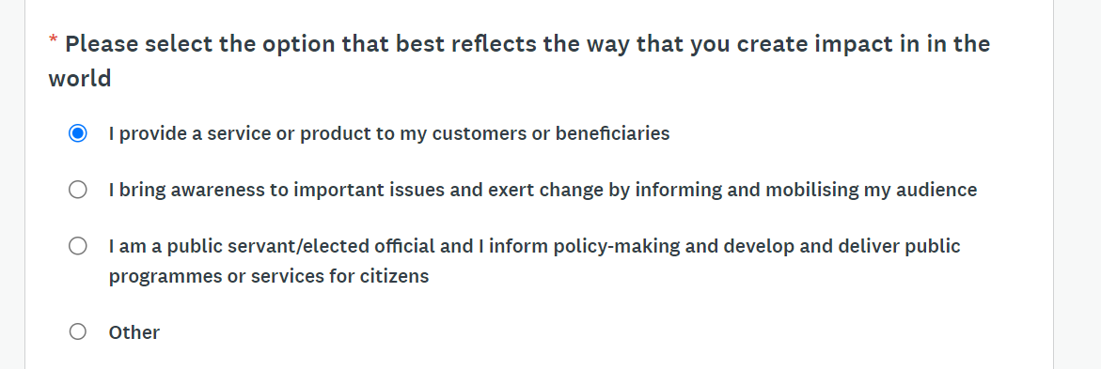

### Define the system you are working with and how are you shifting that system? Would your intervention transform the system completely, how? Who are the allies that work with you in shifting the system?

*(200 words max.)*

We have developed a multi-faceted initiative aimed at empowering Persons with Disabilities (PWDs) within the education system and the workforce. Initially, we provided short-term industry skill training to graduates with disabilities. However, our approach evolved to encompass a broader scope. We now offer comprehensive training for college students with disabilities, ensuring their placement before graduation. Additionally, we educate school students with disabilities to bridge the gap between PWDs and non-disabled individuals. Our expanded initiative strives to seamlessly integrate PWDs into educational institutions and the job market.

Our intervention is transformative as it emphasizes changing mindsets and creating awareness within organizations, colleges, and schools. This shift in perspective is crucial for fostering a supportive environment for PWDs in both educational settings and workplaces. Our collaborations with various allies, such as colleges, schools, NGOs, Corporates, and innovators working on assistive devices, highlight our collective effort toward inclusivity.

Our overarching goal isn't solely short-term training; it's a long-term strategy involving educational preparation, raising awareness, and technological innovations. This comprehensive approach signifies our dedicated effort to shift the system toward a more inclusive society, providing PWDs with equal opportunities and access to education and employment.

### ** Can you please provide us an overview of the impact that your organisation/initiative has created?

*Please see* [*attached*](https://drive.google.com/file/d/1X8aLyEwKQJb7i8I01bvIVIFed1uQiTCB/view?usp=sharing) *document to understand how to provide this information*

*Population of focus: Who is benefiting from your work?*

*Lives impacted*: What’s the breadth of your work? Add Direct and Indirect Impact separately Outputs: What have been the impacts as a result of these activities? Please try to quantify these*

***If you aren't a CEO, Co-Founder, or at an Executive level role in the organisation, please share details about your department/initiative/work specifically.***

*\*Direct and Indirect Lives Impacted: Number of people for whom you have created a substantial/transformational impact in their lives (i.e. ability to manage their lives, income, well-being, etc.). The attached document shows how to calculate lives impacted in your context, however, please mention Direct and Indirect Lives Impacted as a number only.*

|  |  |  |  |  |
| --- | --- | --- | --- | --- |
|  | Population of Focus | Direct Lives Impacted | Indirect Lives Impacted | Outputs |
| Impact | Persons with Disabilities, Women and Marginalized communities (About 700 Million) | 3,000  (Trained, Sensitized) | 9,000  (Including Families of PWDs, Disability Sensitization…) | Our initiatives and activities have fostered a positive ecosystem that benefits not only our candidates (direct beneficiaries) but also extends advantages to companies, parents, families, and the younger generation (indirect beneficiaries) |

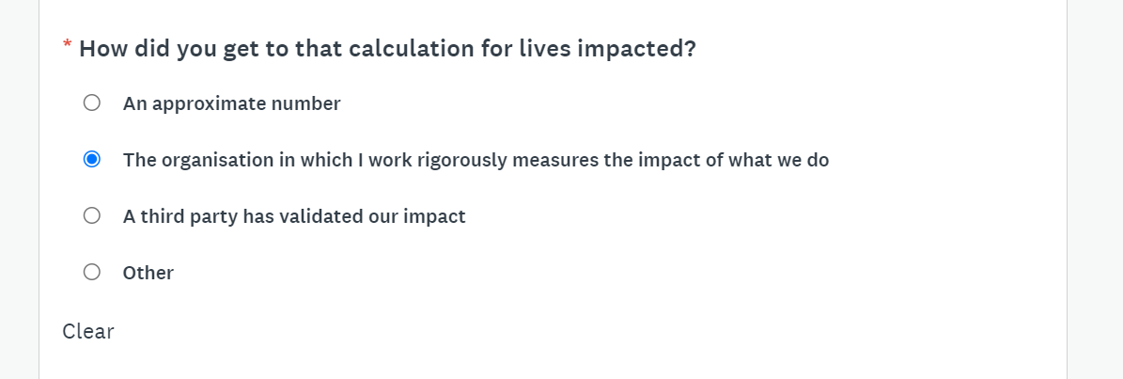

*We capture various metrics diligently and share that with our donors, within WinVinaya and publish many of them it in our website*

### ** What does the impact for your organisation/initiative look like in the next 3 years?

*(150 words max.)*

(No response)

Over a span of three years, the transformation of WinVinaya from a vocational training center into a holistic learning center unfolds. Year 1 entails the foundational phase, involving assessments, vision-setting, curriculum development, facility upgrades, staff training, and community engagement. In Year 2, this vision materializes as we launch high school and college programs, coupled with robust career development services, entrepreneurship initiatives, and an emphasis on scaling and networking. Throughout, diligent monitoring and evaluation for continuous improvement will be key. In Year 3, the organization reaches full-scale, extending education and services to more individuals. Leadership development becomes a core element, complemented by an impact assessment, advocacy for policy changes, and efforts to ensure financial sustainability. The mission remains focused on inclusive education, entrepreneurship, leadership development, and, in the process, creating a positive and enduring social impact for individuals with disabilities.

**\*\* Provide a real example of someone who has benefited from your work to show us what the most significant impact of your work can be.**

(No response)

Jayashree’s journey exemplifies the transformative impact of WinVinaya's work in empowering individuals with disabilities. Born with a locomotor disability, Jayashree faced significant hurdles in education and employment. Our intervention involved equipping her with industry-relevant skills and advocating for organizations to recognize diverse skill sets, adapting selection processes to accommodate different abilities.

As a result of our support, Jayashree obtained an internship and later secured a permanent position in a company, where she has excelled for over four years. Recently, she earned a well-deserved promotion. Her success isn’t solely a personal achievement but also highlights the impact of inclusive employment practices.

Jayashree's employment not only signifies her personal growth but also transformed her role within her family. She became the primary breadwinner, supporting three family members without disabilities. Her journey vividly illustrates the significant societal impact of providing employment opportunities to individuals with disabilities.

Through Jayashree’s experience, WinVinaya's work demonstrates the profound difference that inclusive employment strategies can make in the lives of individuals with disabilities, offering avenues for independence, success, and meaningful contributions to their families and communities.

* **Do you wish to record a video to complement your previous response?**

(No response)

https://youtu.be/baxYr3XPDPM

*We capture various metrics diligently and share that with our donors, within WinVinaya and publish many of them it in our website*

**\*\* Please give an estimate of beneficiaries or customers that are directly served through your product/service/solution, who experience problems of poverty.**

Please see more [here](https://acumenideas.com/the-opposite-of-poverty-8534d6fa7102) about how Acumen thinks about poverty.

(No response)

*We have successfully trained 1062 candidates (which includes Persons with Disabilities) in holistic training – which comprises of Domain/ Technical Training, English Communication and more importantly life skills training. We help them believe in themselves, advocate for their rights, earn an income and lead a life with dignity.*

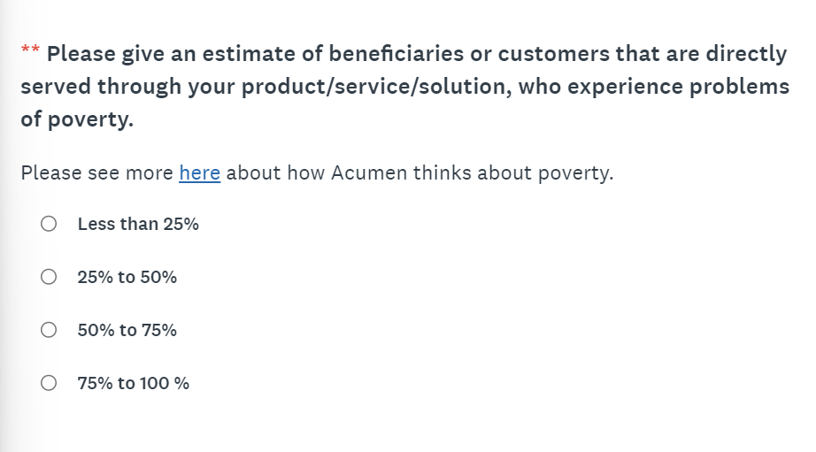

# Additional Information

***WinVinaya Foundation has an inclusive Learning Management Systems called WinVinaya Academy which has won Innovation Award for Assistive Technology from NASSCOM FOUNDATION***

### *Optional:* Please upload any pitch deck/presentation for your organisation/initiative that provides an overview including problem statement, solution, impact, progress, and vision towards sustainability.

***Intro deck to WinVinaya Foundation?***

***Optional:* Please add any other information that you think is important for us to understand the approach or impact of your work, that hasn’t been covered above.**

(No response)

**D: ABOUT YOU AND YOUR EXPERIENCES**

In this section, we want to understand more about you, your previous work, and experiences that have helped shape who you are.

We value all experiences, whether they have been gathered through your school/academic experience, work and practice experience (including volunteering), and/or knowledge, perspectives, insights, and understanding gathered through your lived experiences (direct, first-hand experience, past or present, of a social issue(s)). We want to understand your leadership journey so far.

We will be assessing the content of your answer and **NOT** the polish or smartness of your written English. Please share answers in simple bullet-points vs essays if that is what you prefer. We find that sometimes this can help focus your answers and evidence of your impact on the ground.

### For how many years have you been working at your current organisation/initiative?

*Please round off your experience to the nearest whole number. (i.e. 6.5=7, 6.2=6). Additionally, if you have been working at your current organisation/initiative for more than 30 years of experience, please choose 30.*

(No response)

*I have been working for 8 years in WinVinaya Foundation and for 18 years in the Disability Sector*

*Co-founder and Trustee of WinVinaya Foundation*

### Please describe your primary work activities or responsibilities in this role.

*Please describe your current responsibilities, key targets, and functions that you oversee. (100 words max.)*

(No response)

*I* At WinVinaya Foundation, I fulfill diverse roles. I offer life skills training to individuals with disabilities and women across various age groups, from students to graduates. Additionally, I curate and deliver disability sensitization sessions to corporate leaders and managers. I mentor WinVinaya employees in life skills training and disability sensitization. Moreover, I oversee three key teams:

* The Sourcing Team, mobilizing candidates for our training.
* The Placement Team, connecting candidates with suitable roles and aiding in their integration into companies.
* The Project Management Office, liaising with corporate donors, devising plans, and monitoring funded projects to meet their targets.

### How many people do you directly manage?

|  |  |  |
| --- | --- | --- |
|  | Full Time | Part Time/Volunteers |
| Number | 7 | 10  (Anusha Hana, College Interns…) |

* **How many years have you been in your current role?**

*This might be different from the number of years you’ve been in the organisation/initiative if i.e. you've had multiple roles or if you’ve been promoted.*

*Please round off your experience to the nearest whole number. (i.e. 6.5=7, 6.2=6). Additionally, if you have been working at your current role for more than 30 years of experience, please choose 30.*

(No response)

*8 Years*

*This should highlight your relevant experience that adds to the story of you, your previous work, and experiences that have helped shape who you are and what you do.*

(No response)

I was once a school backbencher, my days revolved around art, dance, and caring for the elderly and children. Books never captivated me, but life had other plans. I married an academic who, unlike me, adored books and excelled in IT. His enthusiasm for learning reignited a spark in me.

In the US, I pursued an Associate of Science in computer science—surprisingly, the subjects I loved—dance, drawing, and sports—were part of the curriculum! Amid diverse classmates, my strength in English shone. My husband helped me learn through examples and storytelling. I excelled in exams and realized that customizing learning methods works wonders. This was my first discovery.

Returning to India, learning continued—medical transcription, metal embossing, and candle making. Parenthood added a new chapter and taught my kids empathy by volunteering in blind schools. Guiding two blind 10th graders for exams, I used a play-based method. They succeeded, revealing the power of teaching through play. This was my second discovery.

Teaching at a special school unveiled a new calling—art-based therapy for kids with diverse needs. It revealed my knack for understanding individual learning styles. Mathematics through movement, English via drama, and budgeting through cooking—learning became an adventure. I discovered my knack for auditory, visual, and experiential learning.

The world of differently-abled individuals captivated me. Drama therapy and movement therapy further honed my skills. I realized my potential in recognizing strengths, curating learning, and driving social change. This was my third discovery.

With my husband, we founded an NGO focused on inclusive skill development. We aimed to create an ecosystem for everyone to learn and thrive. My belief grew stronger—anyone can learn given the right environment, methods, and mentors. "Everyone is good at something." Recognizing their strengths is key.

### Please share a link to your LinkedIn Profile.

*Please write N/A if you don’t have a LinkedIn Profile*

(No response)

*https://www.linkedin.com/in/akila-sankar98/*

### *Optional:* Have you personally received (not for your organisation) any awards or recognition for your work?

*If yes, can you please share the links and details. Yes. Not able to find the award certificate*

(No response)

### *Optional:* Are there any other communities, boards, professional bodies, or similar initiatives related to your work that you’re a part of?

*If yes, can you please share details? If not please type N/A*

*DireDirector of WinVinaya Infosystems India Pvt Ltd*

(No response)

*We are partners of Disability NGO Alliance, Hear a Million*

*(100 words max.)*

(No response)

*I I am in the leadership team for two organizations – WinVinaya Foundation (a Not for Profit entity) and WinVinaya Infosystems India Pvt Ltd (which is a private limited company). Through both these organizations, I focus on providing Diversity, Equity and Inclusion services to candidates across disabilities, corporates, NGOs and more. More than 50% of our employees are persons with disabilities and we focus on tackling poverty, creating future leaders and help them lead a life with dignity.*

### For the following questions, we use the information to better understand who we are reaching, and where we need to work harder to reach leaders from diverse backgrounds and communities. We never use information in this section to assess your individual application.

*Please answer however you feel comfortable*[*.*](https://acumenacademy.org/privacy/) *No matter who you are, this information will not affect your chances of becoming a Fellow.*

### What is the country of your nationality?

(No response)

**Indian**

* **Do you identify as being part of a community that has been historically marginalised?**

(No response)

**No**

***Optional:* Give more details if you can:**

(No response)

* **Which State/Union Territory do you reside in?**

(No response)

**Karnataka**

(No response)

**Bengaluru**

* **How would you categorise the city you mentioned above?**

(No response)

* **Do you identify with having a physical, mental health, or learning disability?**

(No response)

**No, but I enjoy learning through visual, arts, or experiential methods**

* **Do you consider yourself a person with lived experience (i.e. have direct, first-hand experience, past or present) of a social issue(s) and/or injustice(s)?**

(No response)

**No. I have direct experience of working with Persons across disabilities – including persons who are Visually**

**Impaired, Hearing Impaired, Autism, Mental Illness and more.**

**E: ABOUT YOU AS A LEADER**

In this section, we'll ask you to share more about yourself that you haven't already shared in other areas of the application. We're looking to understand who you are, your motivation for applying to this programme, and your vision for your work in tackling issues of poverty.

Why is this important to us? This programme is for individuals who are already deeply committed to the work of tackling poverty, who are interested in being part of a global community that is bound by values. Everyone’s approach and the reason why they began their journey of tackling poverty could be different, but we aspire to build a community of Acumen Fellows who are committed to staying on the path of creating lasting change in society.

To understand more about the values our community stands for, please review [our Manifesto](https://acumen.org/manifesto/). These values act as guiding stars, providing a framework for decision-making in the context of social change.

As stated before, note that we will be assessing the content of your answer and NOT the polish of your written English. Please share answers in simple bullet-points vs essays if that is what you prefer.

### leader?

*Please try to be specific and include examples from your professional life that would help us understand why this would make a difference.*

*(200 words max.)*

(No response)

*F* “*Transforming myself from Enabling individuals to live with Dignity to Building Multiple Leaders who can create a 10X Social Impact “*

*From impacting tens of people in 2016, I grew to impacting 100 people a year in 2019-2021 to positively impacting 300 people in 2022 and enable them to lead a life with dignity. While there is growth, it is very linear. I believe that with the right mentorship and the right eco system, we can significantly enhance the social impact. The number of beneficiaries are in Millions. I need to learn how to transform my mindset, my skills such that we can make a much bigger social impact.*

### ** Challenge and failure are part of the journey. Please share a video telling us about the failure in your professional life, and the lessons you learned from that experience.

*Please try to make this answer relevant to your pursuit of your vision.*

Please select which method you want to submit your video by. This has to be video format only.

(No response)

Challenges in training Persons with Neuro Diversity in Magic Puddles – where I could not see visible improvements in the skills of the candidate even after working for many months and I would come back and cry my heart out on what I should do better to reach out to that kid. But the parents would say that the kid is happy about the class and such.

*I learnt that there are stakeholders beyond the candidates, like parents and it is important to get their feedback to understand the impact we are making.*

Challenges in a school where I was teacher. I found it difficult to navigate through some of the pre-set mindsets, office politics. While I was able to make a difference in the lives of students by teaching them various Math Concepts and Life skills through Play way method, the environment became suffocating, and I quit the organization.

*I learnt the importance of creating and nurturing an open and growth oriented eco system which will enable employees to share their ideas without fear and for the leadership to actively listen, engage in meaningful dialogue and then take appropriate action.*

After becoming a leader in WinVinaya Foundation, my initial role when the organization was small was to impart life skills to persons across disabilities. Along with growth of the organization, I had people reporting to me and I had to learn the ropes of leading them by setting expectations, goals, giving them feedback and such. Here it was a mixed bag. With some people, I was able to get the desired results and for some others who reported to me, I could not extract the best out of them.

*I learnt the importance of setting goals, regular monitoring. More importantly, I learnt that people are different, and I should use different methods with different people to achieve the best results. I am still learning this every day!.*

### ** If selected for the Fellowship, what do you hope to GET from this community and experience? And what do you hope to GIVE to this community?

*After the Fellowship, the graduates become part of Acumen Academy’s alumni community, the Foundry. We would like you to share how you will continue to give and receive from this community. Please be as specific as possible and provide 1-2 examples of how you will contribute and receive support from the Foundry.*

*(300 words max.)*

(No response)

I believe that I am a constant learner and an explorer who enjoys discovering new things and sharing with others. Most of my experience till now has been on directly working with the beneficiaries and positively impacting their lives. I groomed few resources who directly reported to me with mixed results.

While I would like to scale the social impact from hundreds to thousands and ten thousands, I am also afraid whether I will lose the touch of directly working with the beneficiaries. I am anxious and confused.

I am looking for a trusted mentor, peer group who can help me to probe within myself, face my fears, transform myself to significantly amplify the social impact to removing poverty and helping people live with dignity.

This needs to be expanded. Can you give it a shot, Akila?

------------------------------------------------------------------------------------------------------------------------------------------------

With the help of ChatGPT Version - 1

"I'm an enthusiastic learner, passionate about sharing knowledge. My career primarily involves directly aiding individuals in need, offering hands-on support and guidance. I've also provided mentorship to a few team members, resulting in a variety of outcomes.

Looking ahead, I aim to expand our societal impact significantly, from assisting hundreds to potentially thousands or even tens of thousands. However, this pursuit is accompanied by a persistent concern. I fear that as our scope broadens, I might lose the direct and personal interaction I value. This leaves me feeling both excited and somewhat uncertain.

In order to navigate this forthcoming shift, I'm actively seeking the counsel of a trusted mentor or a supportive peer group. Their guidance will be instrumental in helping me address my uncertainties and fears. My ultimate objective is to enhance our collective social impact by focusing on eradicating poverty and promoting dignified lives for all.

Essentially, my goal is to strike a harmonious balance. I want to continue my close, personal involvement while broadening our impact on a larger scale.

Concurrently, I aim to share my insights gained from direct involvement with people in need. I hope to facilitate discussions, exchange impactful stories, and support others in making significant societal contributions."

*Imagine what an ideal future would look like, share all the key stakeholders involved, and how you plan to engage with them to bring about that change. This is not just related to your current role or work. We would like you to think about all your past and future work and how that may contribute towards this vision.*

Please select how you would like to answer this question.

(No response)

## What is the impact you hope to have on your country? How does your work contribute towards that vision?

A I aim to bring about a significant impact in my country through our work at WinVinaya Foundation. Our focus lies in providing specialized skills and opportunities to individuals with disabilities, ensuring they gain industry-aligned training in fields like Full Stack Software Development, Software Testing, and Financial Accounting.

Our efforts result in a substantial increase in the earning potential of our placed candidates, doubling the industry average salary. This, in turn, contributes to empowering Persons with Disabilities (PWDs) and Women by enabling them to secure jobs and lead dignified lives. By sharing our successful training methodologies and practices, we're inspiring other organizations to replicate similar specialized skill programs. This broader scope creates a more inclusive ecosystem that significantly magnifies our social impact—our fundamental goal for the country.

Innovations like the WinVinaya Academy, featuring courses in Indian Sign Language for various specialized skills, and our pioneering cloud-based Learning Management System (LMS), have allowed us to provide training to candidates across 24 different states in India. This extensive reach represents our unwavering commitment to inclusivity, one that ensures that no one is left behind.

Moreover, our comprehensive training spans 18 diverse disabilities, focusing on foundational skills across different education levels. This concentrated effort aims to lay the groundwork for a more inclusive and diverse future for India, marking our primary contribution to the nation's progress.

* **Have you taken any online courses from Acumen Academy (formerly known as +Acumen courses)?**

(No response)

**No**

* **How did you first learn about this programme?**

(No response)

**Through and Acumen Fellow – Mr Gopal Garg**

* [**Acumenacademy.org**](http://acumenacademy.org/) **is committed to protecting and respecting your privacy, and we’ll only use your personal information to administer your account and to provide the products and services you requested from us.**

From time to time, we would like to contact you about our products and services, as well as other content that may be of interest to you. If you consent to us contacting you for this purpose, please tick below to say how you would like us to contact you:

## No Responses Selected

### consent to us storing your personal data for this purpose, please tick the checkbox below.

*You may unsubscribe from these communications at any time. For more information on how to unsubscribe, our* [*privacy practices, and how we are committed to protecting and respecting your privacy, please review our Privacy Policy*](https://acumenacademy.org/privacy)

## No Responses Selected

Participants are expected to attend ALL programme Seminars (3 residential Immersives - 2 of them virtual workshops) which will include travel to different locations within India. Once selected all programme-related expenses during the Fellowship are provided by Acumen Academy India. The dates of the seminars will be communicated to candidates in the final stage of the selection process.

The Acumen Academy India team and its partners are investing a significant amount of resources, effort, and time into this programme, and we must ensure that all participants are committed. All selected Fellow Candidates must attend all programme seminars (immersives and workshops) and complete assignments between immersives or face possible removal from the programme.

Upon successful completion of the programme, the Fellows become part of Foundry, Acumen Academy’s alumni community of 1300+ members.

The Foundry members gain access to online resources, financial capital, expert mentorship, and opportunities to showcase their work and expand their reach. Foundry members are also expected to contribute to the Foundry with their knowledge, skills, and expertise.

Your dedication to solving the problems of poverty is central to your selection in the Fellows Programme. If selected, you must commit to continue working in a leadership capacity in that path in 2024-2025.

The Fellowship is an adult educational leadership programme. Our responsibility is to create a productive learning environment where participants can understand and practise the content of the programme as best as possible. If selected, you understand that your responsibility is for your own health and safety throughout the duration of the programme. The Acumen team does not provide medical advice, therapy, legal advice, or personal counselling, and by participating in the programme you understand that the programme is not a substitute for professional advice by legal, mental, medical or other qualified professionals.

All candidates in the final stage of the selection process are expected to attend a two day virtual Selection Conference (ceremony in which the final cohort is selected) on February 2nd and 3rd, 2024.Participants are expected to cover their own travel expenses, as well as accommodation(*), if selected all programme-related expenses will be provided by Acumen Academy. If selected, you must commit to attending the Selection Conference.

(*) Note: The Acumen Academy India team wants to ensure that all shortlisted candidates are able to attend, regardless of their financial situation. As a result, in some special situations and upon request, The Acumen Academy

India team will consider providing financial assistance to finalists who cannot cover the cost of travel to attend the Selection Conference.

**\* I hereby verify that the above information is true and correct to the best of my knowledge and belief. I affirm that the above responses and essays are original and not plagiarised. I understand that misrepresentation or plagiarism of any kind is grounds for immediate disqualification from the selection process.**

## No Responses Selected

### Submission Instructions

In order to submit your application you will first need to **complete all tasks** (Contact Information, Eligibility for the Acumen Fellowship and Online Application Form) within your application. Also, if you've selected to directly upload a video within this platform, after clicking the green button "Mark as Complete" below you'll be able to see new tasks depending on the video you'll be uploading so that you can do so.

Once all tasks are complete, submit your application by performing the following steps:

1. After you have marked all tasks as complete, you can select **Review** or **Submit** your application.
2. Please review your application before submitting it. Once submitted, you won’t be able to make any further changes to the application.
3. Once you've reviewed all your completed tasks, click **Submit**.
4. Confirm submission by clicking **Submit** once again.

To confirm your application was submitted successfully, you will receive a confirmation message upon submission, as well as a confirmation email.